Assignment 3
Inter-VLAN Routing Basics (Router-on-a-Stick & Layer 3 Switch)
Shreya Panchal

Task 1

Question
Create three VLANs named Foodies (VLAN 10), Shoppers (VLAN 20), and Streamers (VLAN 30) in Cisco Packet Tracer and assign at least one PC to each VLAN.

Theory
Inter-VLAN Routing allows devices in different VLANs to communicate using a router or Layer 3 switch. Each VLAN is assigned a unique network, and the router acts as the gateway between them.

Practical Steps
Create VLANs on Switch
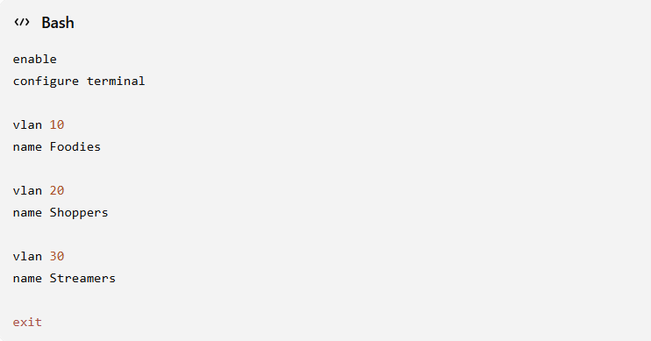
Assign Ports
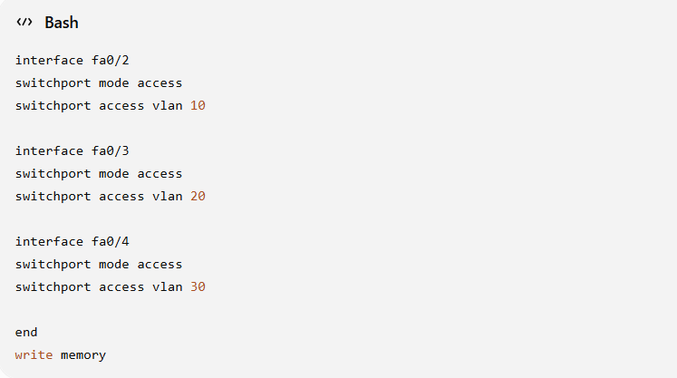
Verify
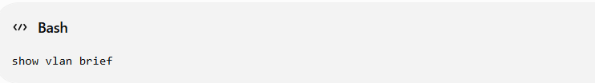
Practical Image 1
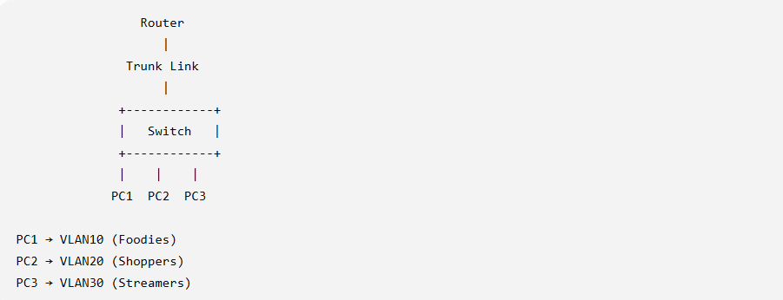
Three VLANs created and PCs assigned.

Task 2

Question
Configure Router-on-a-Stick using sub-interfaces so that all VLANs can communicate.

Theory
Router-on-a-Stick uses one physical router interface divided into multiple logical sub-interfaces. Each sub-interface is assigned a VLAN ID and IP address to route traffic between VLANs.

Practical Steps
Configure Trunk Port on Switch
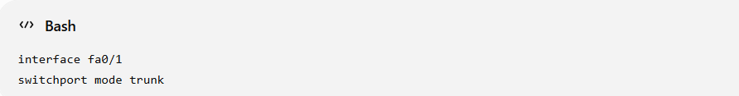
Configure Router
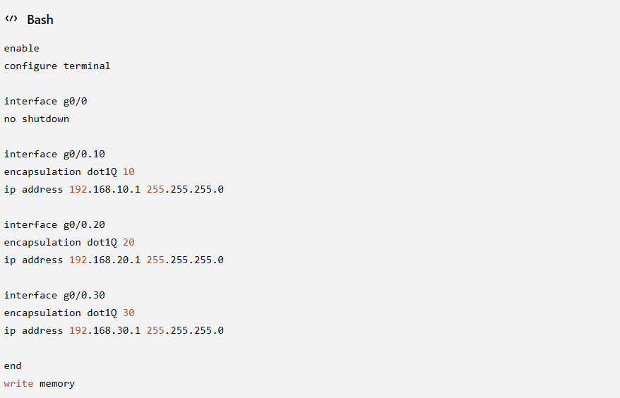
Verify
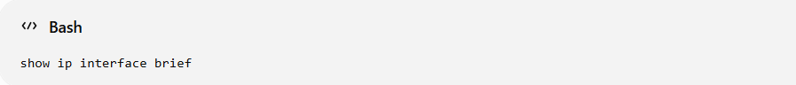
Practical Image 2
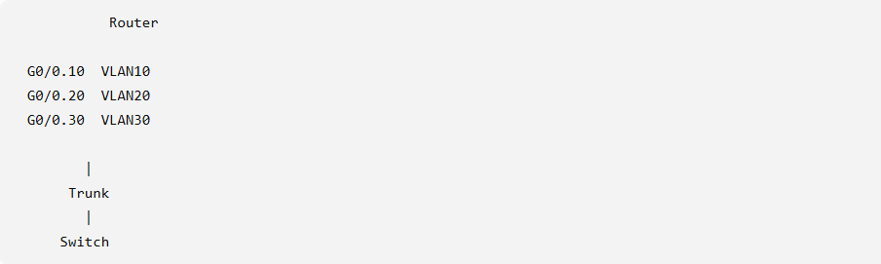
Router configured with three sub-interfaces.

Task 3

Question
Assign IP addresses to each PC and configure the correct default gateway.

Practical Steps
Device | VLAN | IP Address | Default Gateway
PC1 | VLAN10 | 192.168.10.10 | 192.168.10.1
PC2 | VLAN20 | 192.168.20.10 | 192.168.20.1
PC3 | VLAN30 | 192.168.30.10 | 192.168.30.1

Test
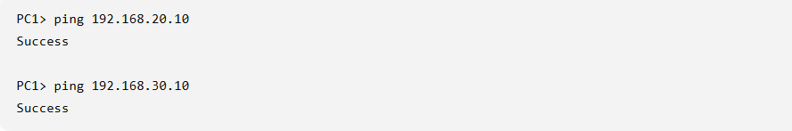
Practical Image 3
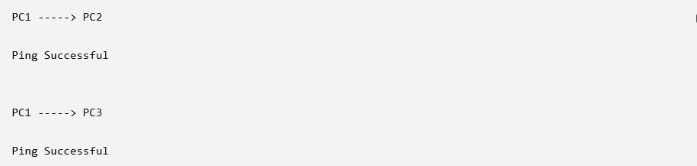
Inter-VLAN communication is successful.

Task 4

Question
Assume users in Shoppers VLAN (20) cannot ping Streamers VLAN (30). Identify and fix the problem.

Theory
Inter-VLAN routing fails if there is a wrong VLAN assignment, trunk configuration error, missing router sub-interface, or incorrect default gateway.

Troubleshooting Steps
Check VLAN
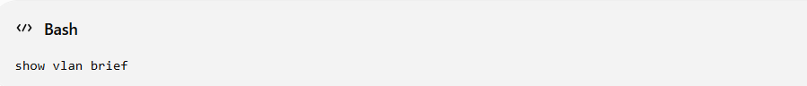
Check Trunk
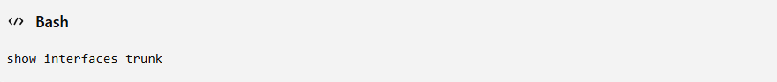
Check Router
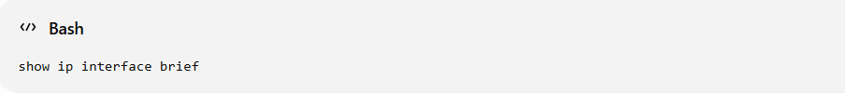

Solution
• Verified VLAN assignment.
• Enabled trunk port.
• Configured Router sub-interface correctly.
• Corrected default gateway.

Result
After fixing the configuration:
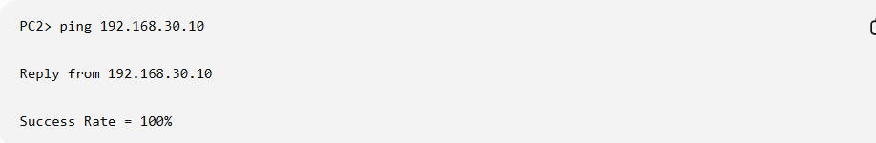
Practical Image 4
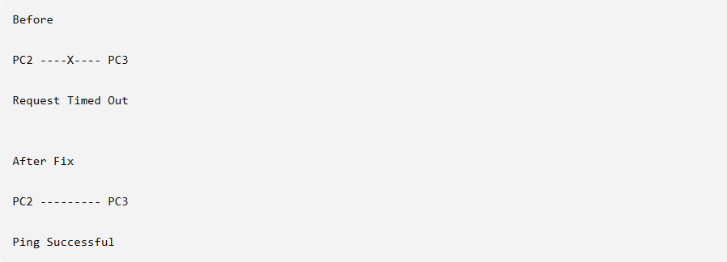
Connectivity restored after troubleshooting.

Task 5

Question
Compare Router-on-a-Stick and Layer 3 Switch.

Answer
Feature | Router-on-a-Stick | Layer 3 Switch
Advantage 1 | Low Cost | High Speed
Advantage 2 | Easy to Configure | Better Performance
Disadvantage 1 | Single Link Bottleneck | Higher Cost
Disadvantage 2 | Slower for Large Networks | More Complex Configuration

Practical Image 5
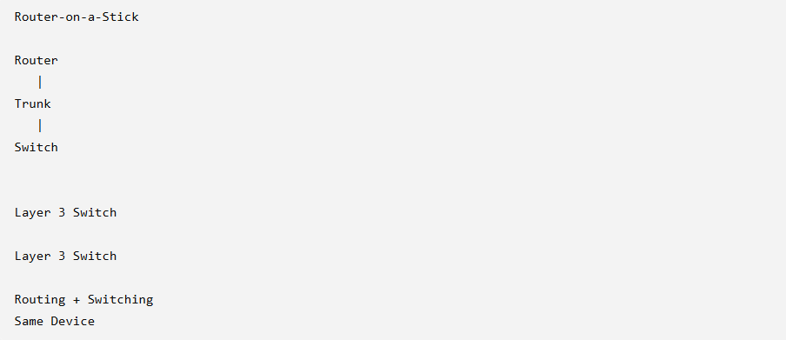
Comparison of Router-on-a-Stick and Layer 3 Switch.

Conclusion
In this practical, three VLANs (Foodies, Shoppers, and Streamers) were created and connected using the Router-on-a-Stick method. Router sub-interfaces were configured with 802.1Q encapsulation, IP addresses were assigned to all PCs, and successful communication between different VLANs was verified. A troubleshooting scenario was also performed to identify and fix an Inter-VLAN routing issue. Finally, Router-on-a-Stick was compared with a Layer 3 Switch, highlighting their advantages and disadvantages.

